**About iterator**

YouTube tutorial:

https://www.youtube.com/watch?v=o9ZYhHdZJNY

**import** java.util.*;

**class** apples {

**public** **static** **void** main(String args[]) {

LinkedList<String> animals = **new** LinkedList<String>();

animals.add("fox");

animals.add("cat");

animals.add("dog");

animals.add("rabbit");

Iterator<String> it = animals.iterator();

**while**(it.hasNext()){

String value = it.next();

System.*out*.println(value);

**if**(value.equals("cat")){

it.remove();

}

}

System.*out*.println();

// Modern iteration, Java 5 or later

**for**(String animal : animals){

System.*out*.println(animal);

//animals.remove <--won't work in for-each loop

}

}

}

The result is:

fox

cat

dog

rabbit

fox

dog

rabbit

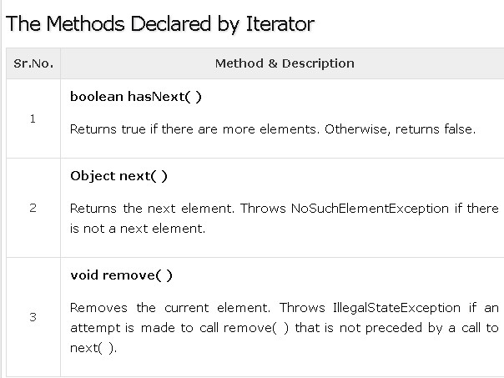

ListIterator extends Iterator to allow bidirectional traversal of a list, and the modification of elements.

